**DEVELOPING A CHATBOT**

**Building Chatbot And Integrate To Application**

|  |  |
| --- | --- |
| TEAM ID | PNT2022TMID41739 |
| PROJECT NAME | Smart Fashion Recommender Application |
| TEAM MEMBERS | PADMANABHAN.S ASWIN RAJ.M  HARISH.M JANAKAR V |

Building Chatbot

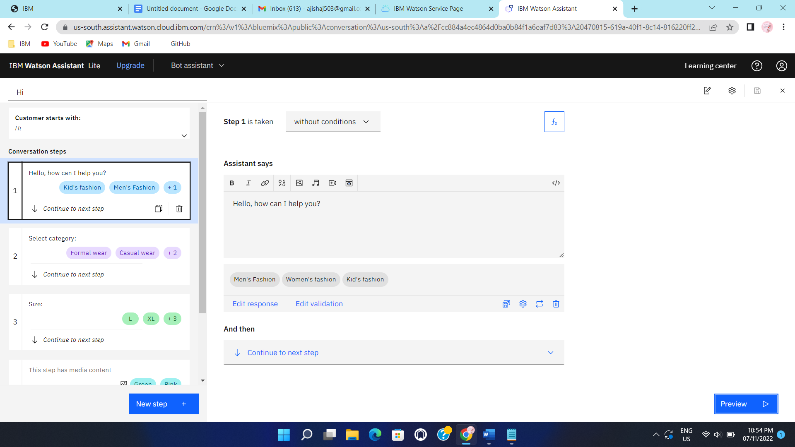

Chatbot Integration

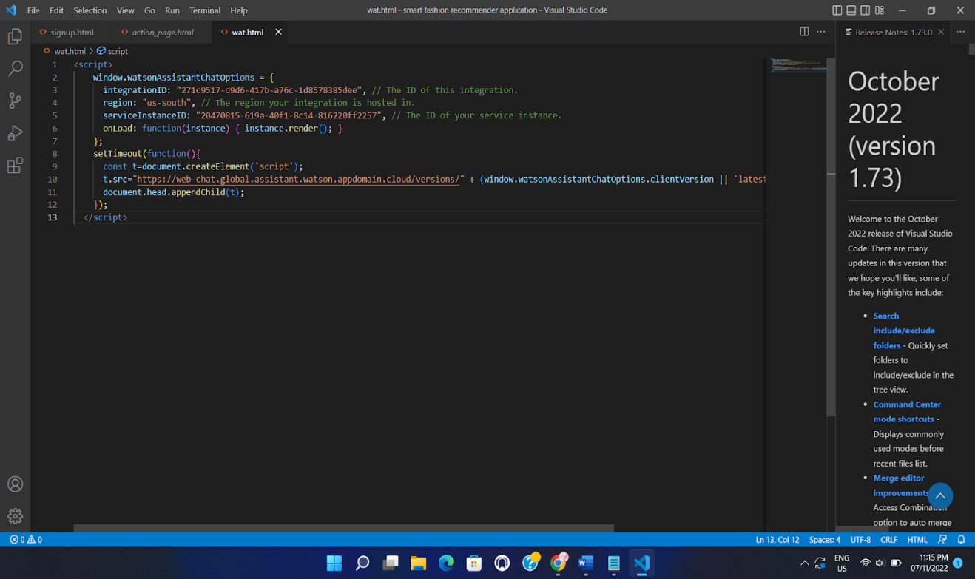

CHATBOT

